
QUALITY ALERT

Customer: ChamClad Date: October 01, 2023
Die: 15766 Customer NCR:
Type of Complaint: ChamClad COMPAINTED

Description: ChamClad COMPLAINTED – Material has a curved at the nailing fin causing will be created bubbles when laminating process.

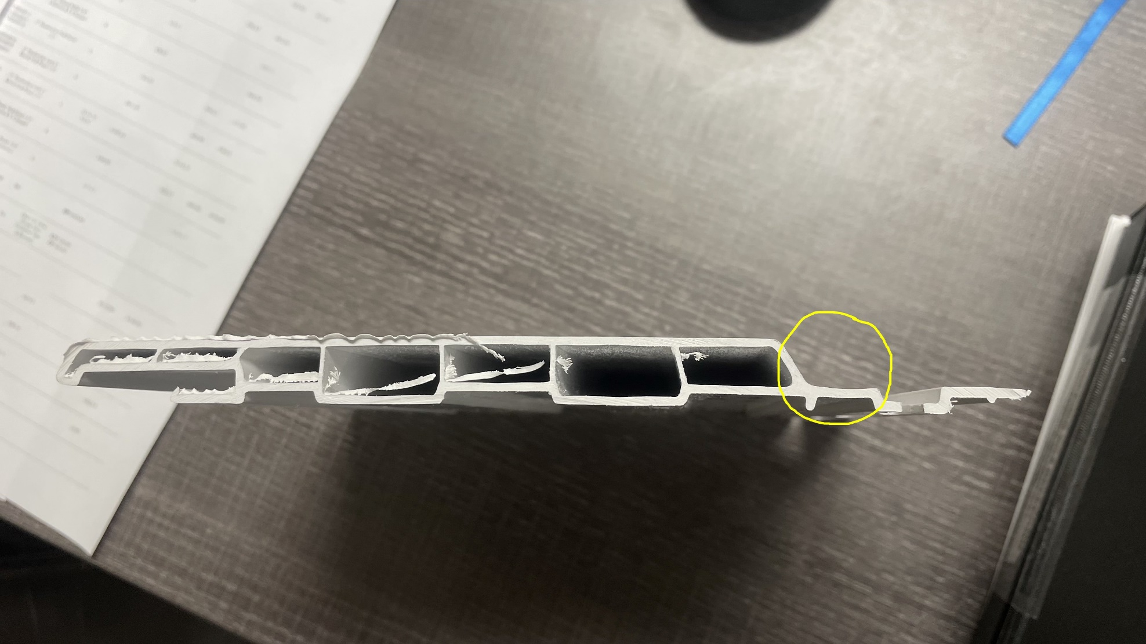

PLEASE RUN AS FLAT AS POSSIBLE AT THE NAILING FIN

BY SIGNING BELOW, YOU ACKNOWLEDGE THE PROBLEM ABOVE AND AGREE TO MONITOR THIS ISSUE IN FUTURE PRODUCTION RUNS.
DAY SHIFT |  | AFTERNOON SHIFT |  | NIGHT SHIFT
NAME | SIGNATURE | NAME | SIGNATURE | NAME | SIGNATURE

